School Council 2018-2019
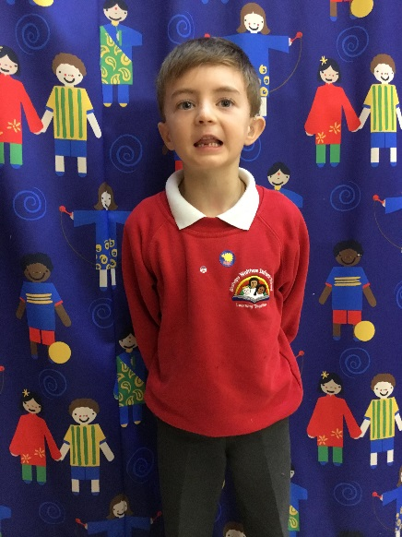
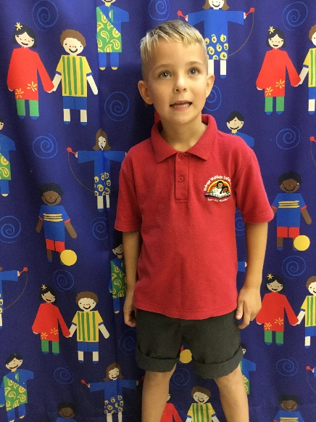
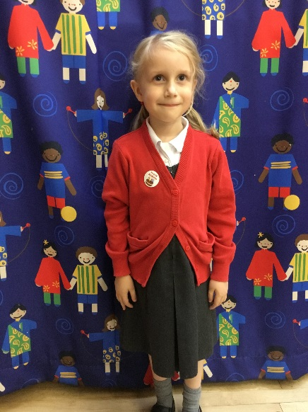
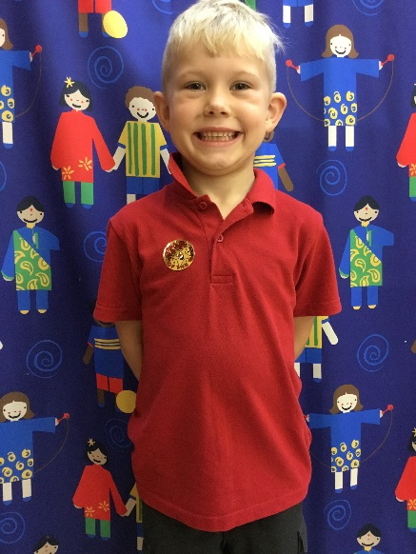
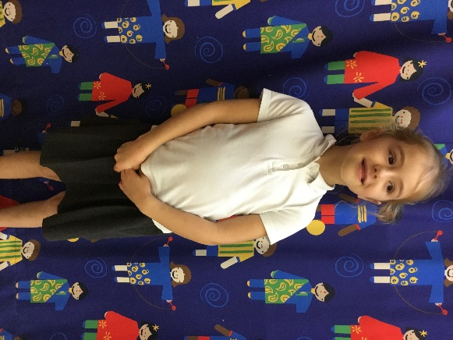


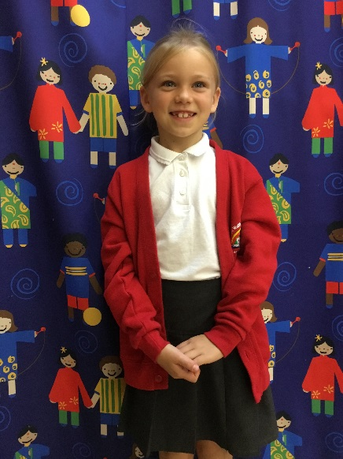

AUTUMN TERM 2018
Thursday 4th October 2018
We met to take photographs of the new School Councillors. Next Friday we have Open Morning and visitors will be told to look out for School Councillors to ask them questions about what makes our school so special.

Thursday 11th October 2018
We met in our new building.
School Councillors discussed their role
-Talk to your class and bring their ideas to meetings.
-Help your school to be a happy and safe place.
-Voice for the children in the school.
-Speak at Governors meetings to let them know what we have been doing.

None of the School Councillors were asked any questions by visitors at Open Morning. Rosie thought they might have been a bit scared to come in the classrooms!!

Children In Need - November 16th 2018
IDEAS FOR RAISING MONEY
-Cake stall
-Toy sale
-Drinks
-Guess the number of sweets in the jar.
-Children's clothes/ jewellery
-Tombola

Thursday 18th October 2018
We met today to begin planning our fundraising and assembly for Children in Need.

Thursday November 1st 2018
Today, we planned our Children In Need day
we are holding a cake sale on Friday 16th November and dressing in spotty clothes. Also, there will be a guess the number of sweets in the jar for £1 a go. The prize is the sweets and a teddy.
A letter is going home tonight to tell everyone about what we are doing.
The School Council are holding a special assembly on Wednesday 7th November all about Children In Need.
Each class needs to watch the video about Children In Need and make some cake sale posters.

Wednesday November 7th
We held our launch assembly for Children in Need. Well done School Councillors for coming out to the front to speak to the rest of the school.

Thursday November 8th
We met briefly to discuss next Friday's Children in Need fundraising day. Thank you to all the classes for the super cake ale posters which we have put up around the school. Please can you ask all the children if there are any parents, carers, grandparents etc. who could come and help from 2pm next Friday afternoon.
Remember, guess the number of sweets in the jar starts on Monday and you can win the sweets and a teddy.

Friday 16th November
We raised an amazing £464.33! Well done School Council for all your hard work and a big THANK YOU for all the yummy cakes and super spotty outfits.

Friday 23rd November
We met to talk about our amazing Children in Need day and talk about ideas for the Year R outside area.

SPRING TERM 2019
Friday 18th January
We had a look at the new part of the school and the library. There was lots we liked about it but also some good ideas to make it even better.
Red Nose day is on Friday 15th March. Mrs Charles has ordered some noses to sell and we will wear something red on the day in exchange for a donation. School Councillors suggested letting parents/carers know as soon as possible, so they have lots of time to look for red clothes.
We now have new covers for our School Council folders with our new class names on.

Friday 25th January
A brief meeting to talk about how we could help our community and maybe work towards some community values or rules.

Friday 15th February
Thank you Otter Class for your feedback about the library. You are enjoying all the new books but did ask if it could be decorated with some pictures. this is going to happen soon, watch this space!
After half term, the new Science and Maths shed will be opening. It is next to the pond and Mrs Charles and Mrs Moth will talk about it in assembly. Thank you School Council for giving me some more ideas about what to put in there.We talked about feeding the birds so we will have lots to watch with the new binoculars in the shed.
Red noses will be on sale after half term.

Friday March 1st
We are having lunch with our school caterers, HC3s on March 28th to talk about the summer menu and give our ideas for meals.
Today we looked at the new menu and discussed some of the meals that we have not had before. We are asking our classes what they think about the new meals and completing a class survey. Mrs Mills will be given the results and if we're lucky, might even make us some food to taste!
We talked about Red Nose Day (Comic Relief). Nose are now for sale for £1.25, come and buy yours from Mrs Barnes and Mrs Greenwood.
Henry asked who Red Nose Day helps. It is children and young people in the UK and around the world who either need special help or live in some of the world's poorest communities.

Friday 15th March
RED NOSE DAY!
Well done everyone, we raised £210.37 for children around the world who need help. And we sold out of red noses, a great effort, thank you everyone.
We looked at the survey about the new meals. Mrs Mills will be given the results and decide which meals she will cook for you to try.

Monday 18th March
School Councillors came to the School Governor meeting. They introduced themselves and talked to the Governors about what they have been doing this year.

Wednesday 20th March
Thank you Mrs Mills for the cheese and onion pasty, vegetable wrap and apple shortbread which was tried by all the children in Year 1 and 2.

Friday 22nd March
Well done to School Councillors for speaking to the Governors, you did a great job.
Year 1 and 2 loved the apple shortbread, quite liked the cheese and onion pasty, but weren't so keen on the vegetable wrap.
Mrs Charles has emailed Sarah (Police Community Support Officer) and Michael (Accredited Community Safety Officer) to ask them to come and meet with the School Council. We would like to talk to them about how the children at Bishops Waltham Infant School can help keep Bishops Waltham a happy and safe place to live.
Thursday 28th March
We had a delicious lunch with our school caterers (HC3s) today. They were very impressed with our ideas for new meals and listened to our views on the current and new menus. After Easter, we're hoping to have jacket potatoes as an extra choice on the menu.

SUMMER TERM 2019
Thursday 2nd May
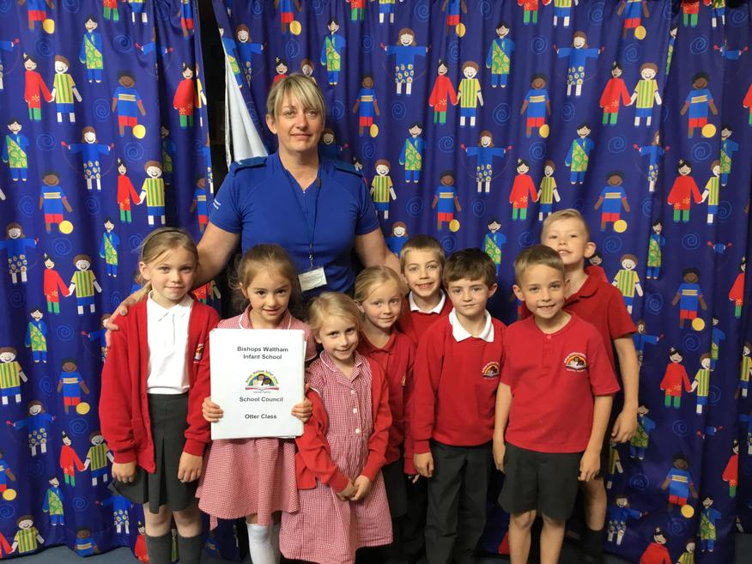
PCSO Sarah McCulloch met with the School Council to talk about community values and how the children at Bishops Waltham Infant School can help keep Bishops Waltham a safe and happy place to live.

Friday 17th May
We met to plan our presentation to the School Governors on Monday. We will be telling them about what the School Council have been working on.
Monday 20th May
The School Council attended the Governors meeting today. Each School Councillor introduced themselves and reported back about our work with HC3s, the school caterers and PCSO Sarah McCulloch.

