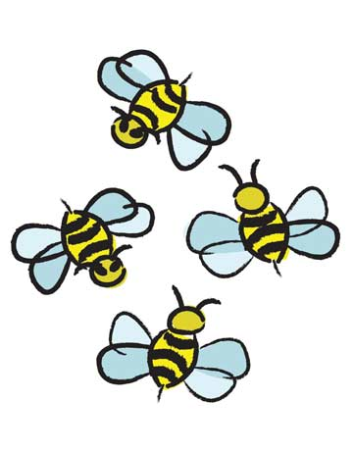
In the garden

In the garden…

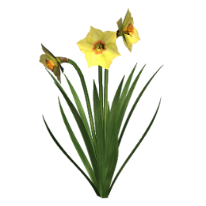
I can see the bright yellow daffodils waving in the breeze.

I can hear beautiful birds singing sweetly.

I can smell sweet scented roses.

I can taste juicy ripe raspberries.

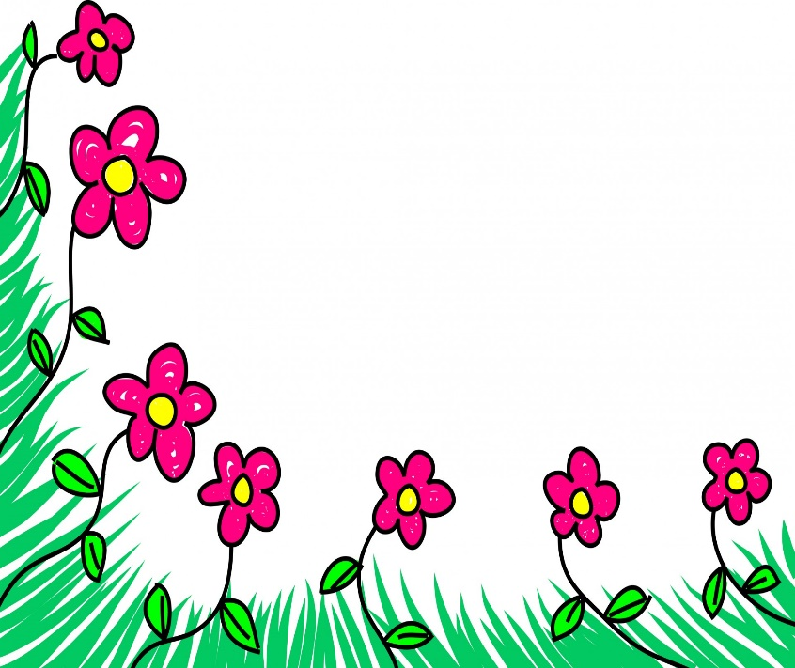
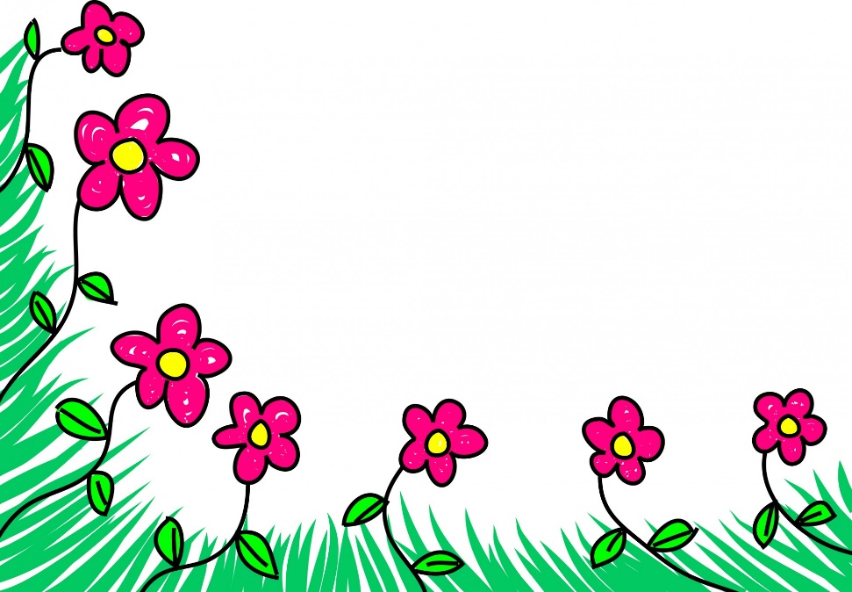
I can feel the prickly cold grass beneath my feet.

