In the Garden
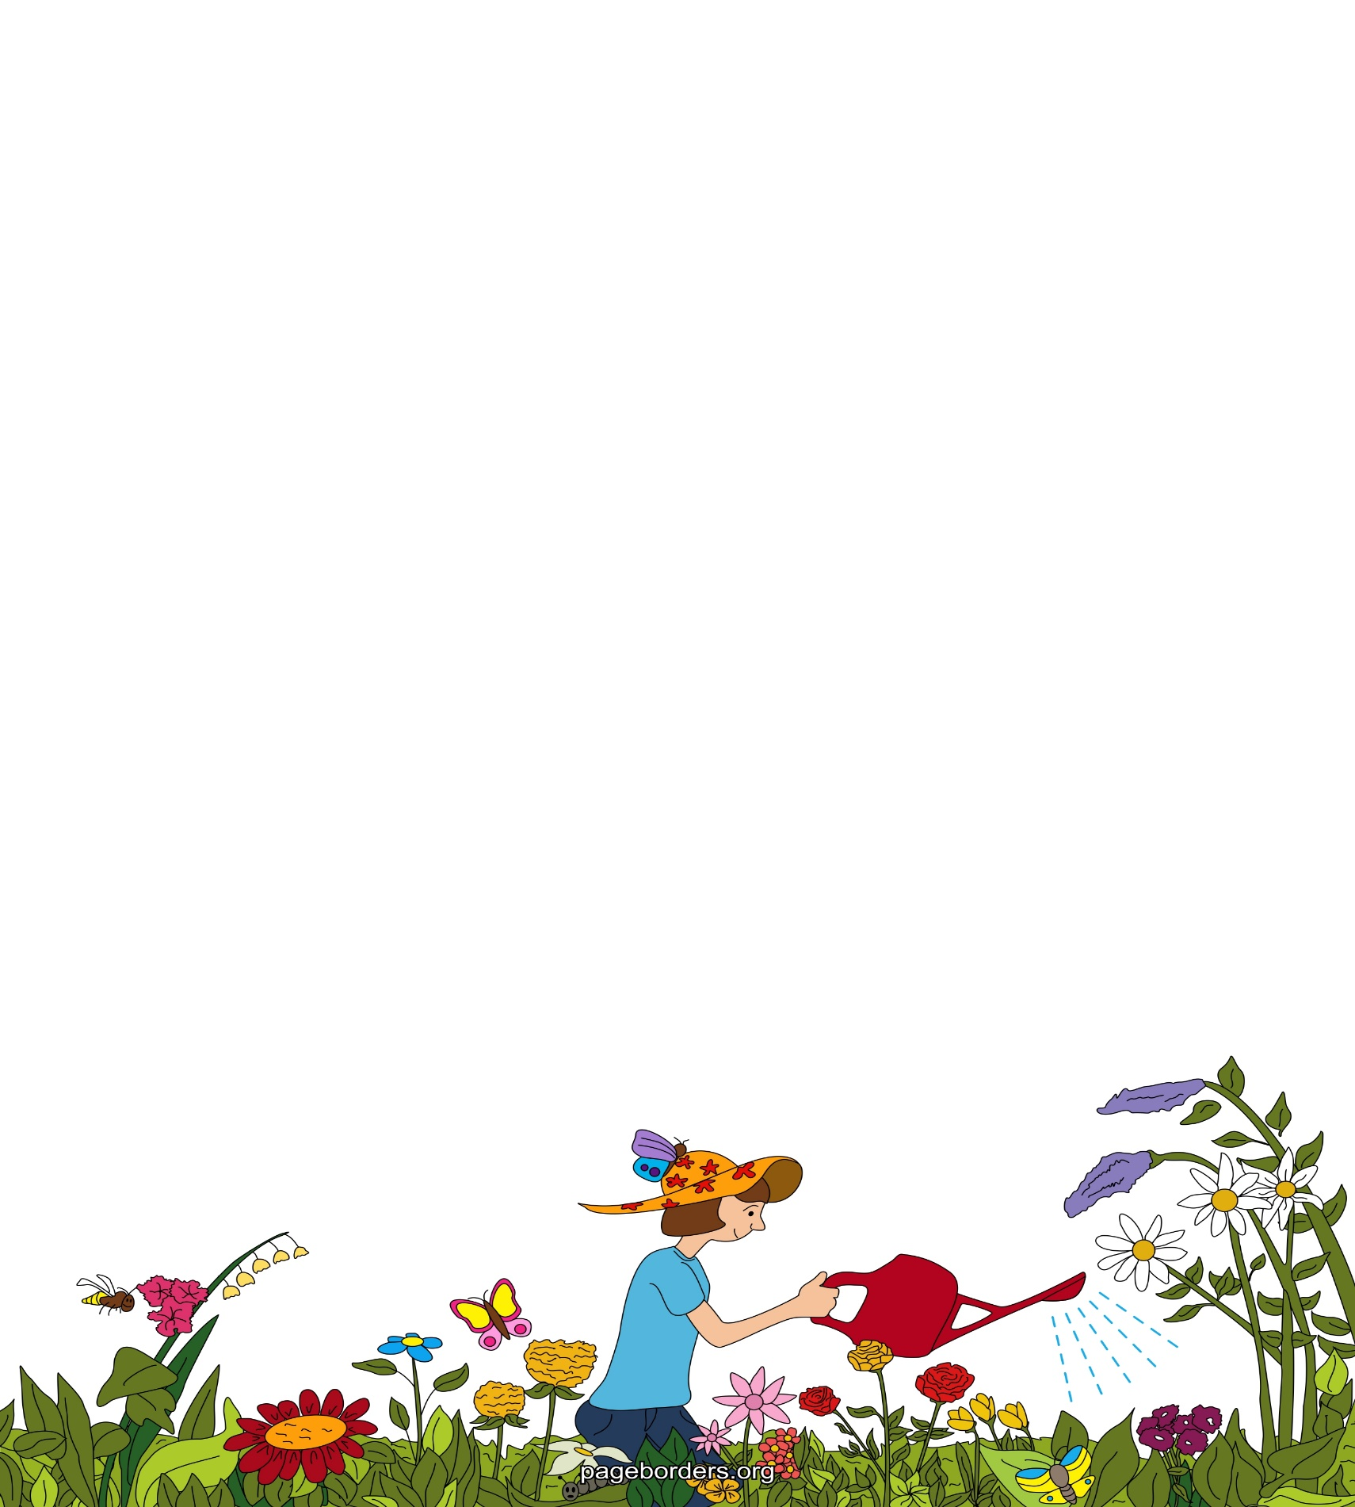
In the garden…
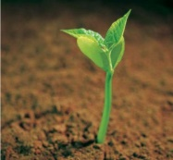
I can see little green shoots peeping out of the soil.

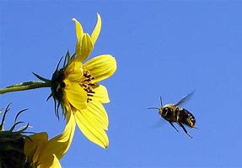
I can hear the bees buzzing from flower to flower.
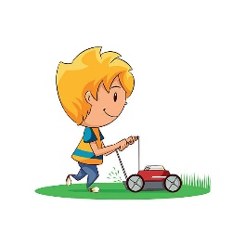
I can smell the freshly cut grass.

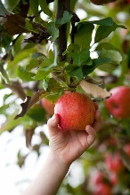
I can taste a crunchy red apple picked straight from the tree.


I can feel the breeze blowing on my face.

