In the Garden
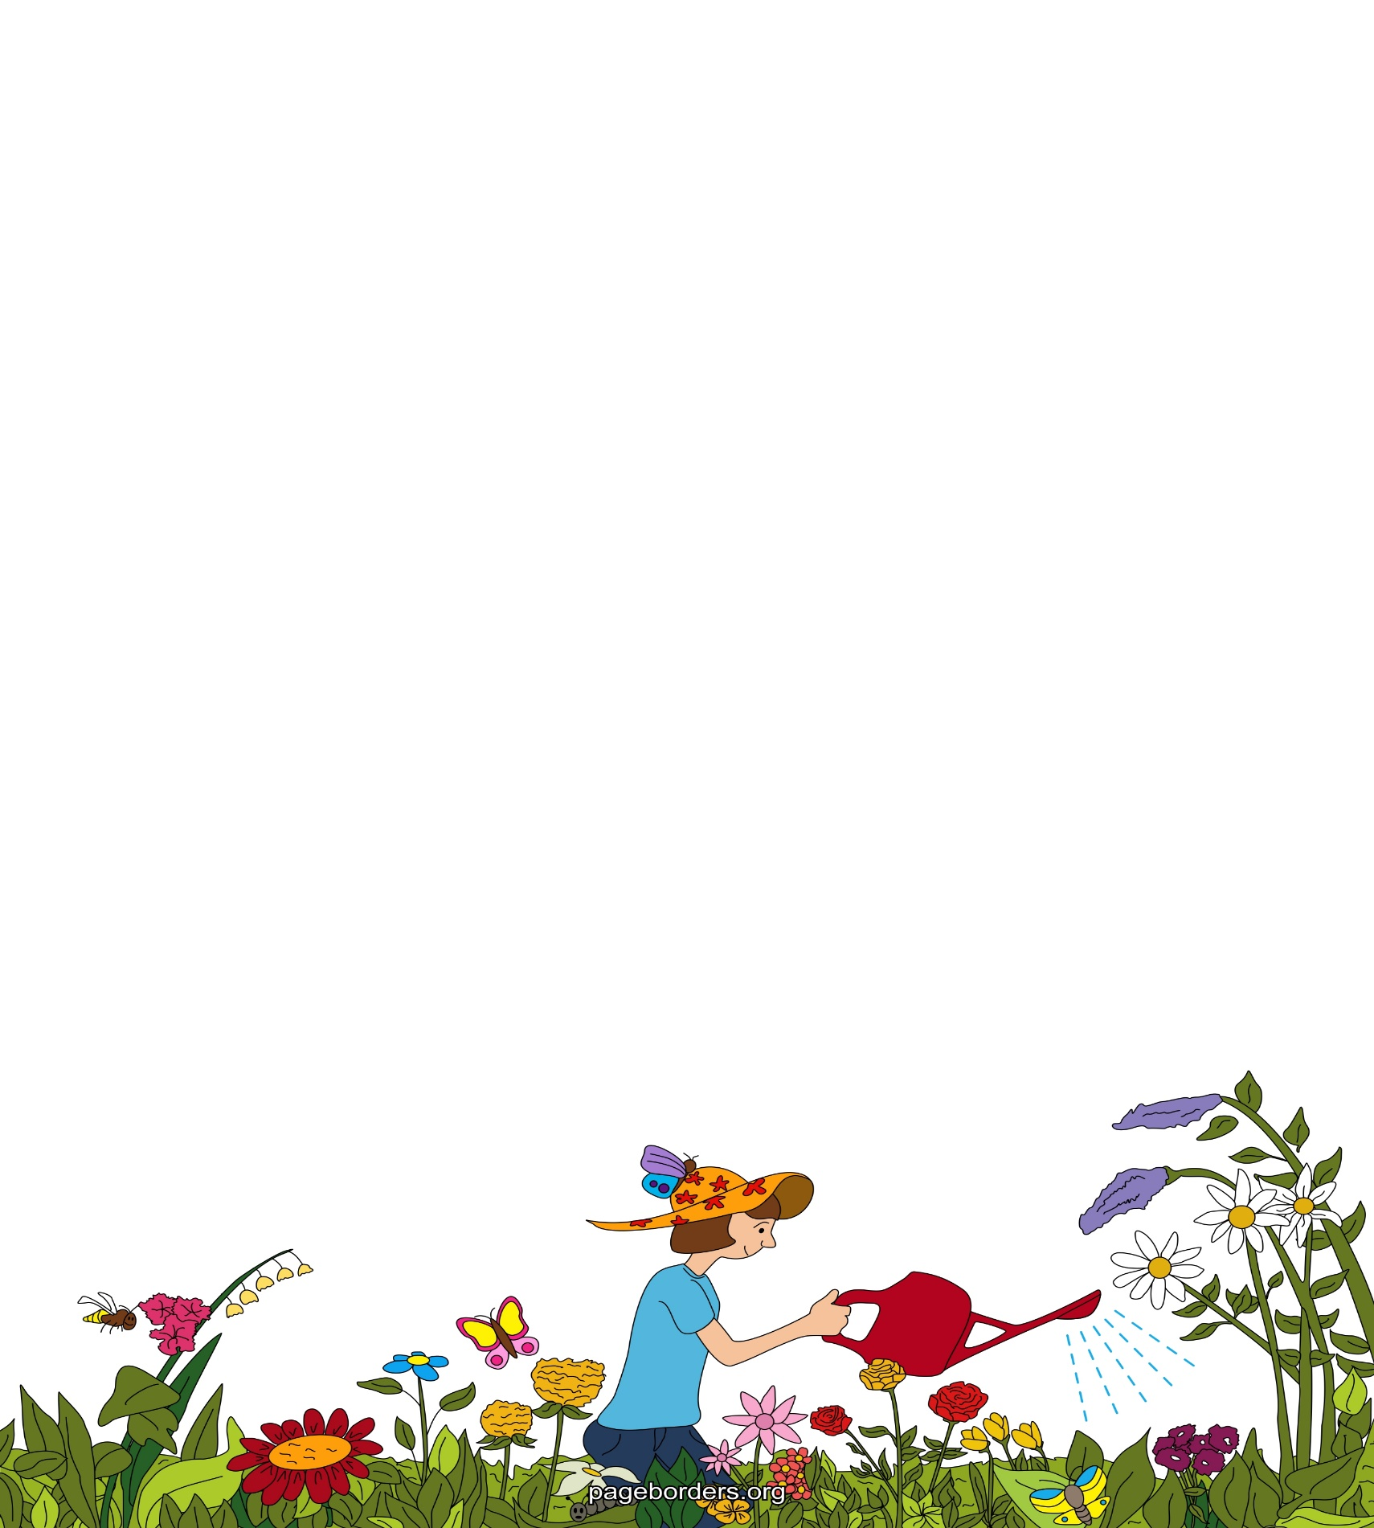
In the garden…

I can see

I can hear

I can smell

I can taste

I can feel

