School Council 2017-2018

Magpies: Vann and Arabella
Woodpeckers: James and Daisy
Blackbirds: Bella and Jack
Robins: Edo and Lyra

Meeting 11 Thursday 8th March
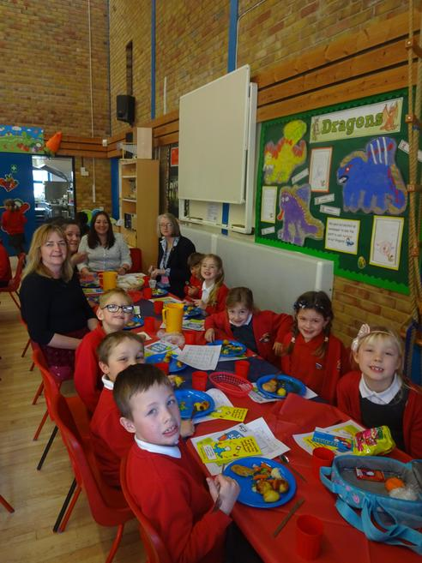
Today, we had a special lunch meeting with HC3s, our school caterers. We looked at the new menu, talked about the meals we like most and those that we are not so keen on. We also suggested some new ideas for meals and HC3s loved Arabella's idea of honey sausages. Mrs Mills is going to make some of the new meals for us to try and we will let HC3s know what we think.
Meeting 10 Thursday 8th February
We looked through the thinking hats sheets and planned what we could do to solve some of the problems. Mrs Charles will start putting some of these plans into action soon, with help from the School Council.
Meeting 9 Friday 19th January
We talked about the new date for our HC3s lunch - March 8th. We will also now get to see the new menu which starts after the Easter holidays.
School Councillors have taken a Thinking Hats sheet back to their classes to help children think about the good things about our school and what needs to change or improve.
Meeting 8 Friday 12th January
The bins have arrived and look great, thank you to our PTA for buying them for us. Bella liked the Gingerbread Man on the fox bin. Edo and Arabella noticed that the writing on the mouse bin looks like cheese. The School Council think that the new bins are encouraging children to keep the playground tidier. What do you think?
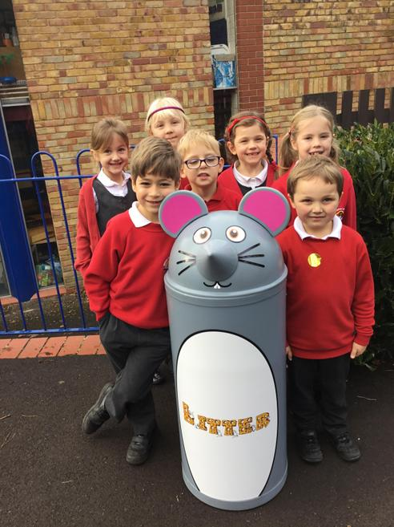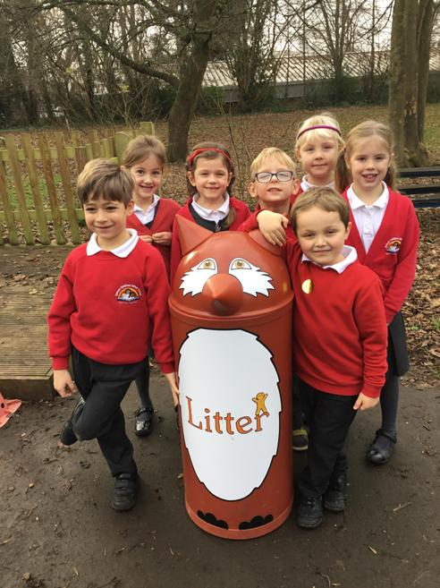
Meeting 7 Thursday 7th December
The PTA have kindly agreed to pay for the new bins and Mrs Palmer has ordered them. Hopefully they will arrive before the Christmas holidays.
On January 11th, the School Council will be attending a lunch meeting with HC3s who are the caterers that provide our school lunches. Councillors will be asking their classes which meals they like best, which they are not so keen on and if there are any new meals they would like to see on the menu.
Meeting 6 Thursday 23rd November
All classes voted on which bin they would like. Five classes voted for the fox and one class voted for the mouse. The School Council have written a letter to the PTA to ask for some money to pay for them.
Friday 17th November
CHILDREN IN NEED
We raised an amazing £448.61. Thank you to everyone who helped and sent in a donation and cakes. The children looked amazing in their spotty outfits! Well done School Council for organising the event.
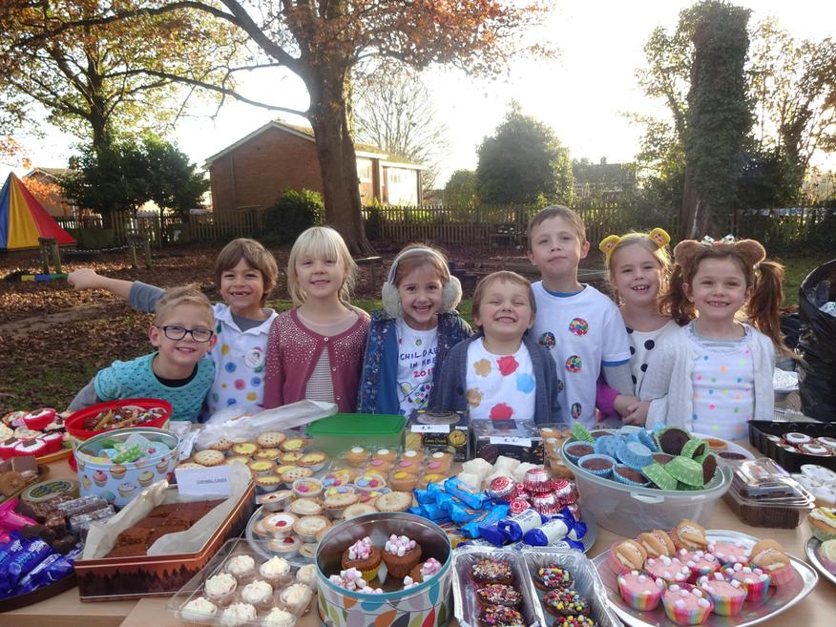
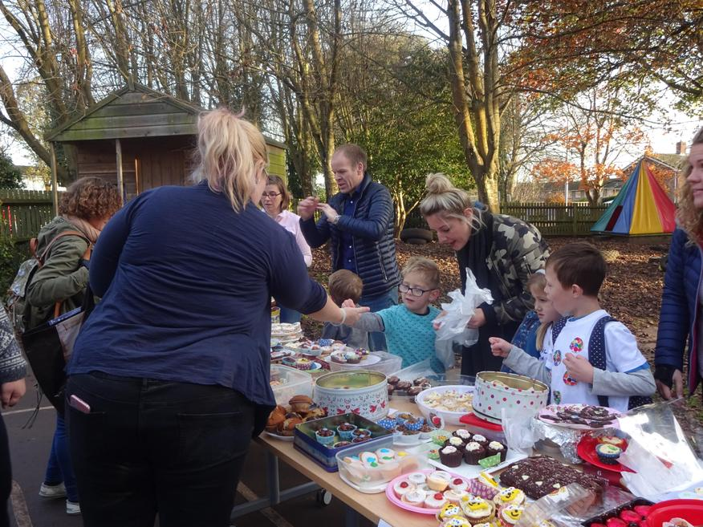
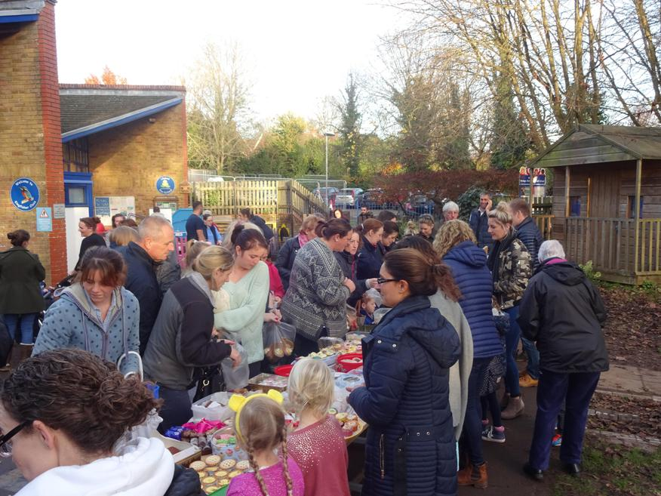
Meeting 5 Friday 17th November
We met to discuss and organise the Children in Need cake sale this afternoon.
School Councillors have also taken some pictures of woodland animal bins for the classes to vote on which they like best.
Tuesday 14th November
The School Council led an assembly in front of the whole school to tell them about Friday's Children in Need cake sale and dress in spotty clothes day.
Meeting 4 Thursday 9th November
We met briefly to plan our Children in Need assembly next Tuesday.
Monday 9th November
The School Council came to the Governors' meeting. They introduced themselves and talked about the work they have done so far to help school.
Meeting 3 Thursday 12th October
We had lots to talk about today!
1. Lyra and Edo were asked questions by visitors yesterday and found our ideas useful when talking to them.
2. Most School Councillors took part in this morning's 'Walktober' event and air pollution fact hunt. We will be doing more work about this.
Remember: Try to park and stride. Parents and carers turn of your engines when parked outside school. Ride a bike or scooter to school instead of coming in the car.
3. We need some new bins for the playground. Each class is going to vote and we will see which is the most popular choice.
4. We will be raising money for Children in Need again this year. The School Council will hold a special assembly after half term to introduce what we are doing.
Friday 29th September
School Councillors helped at our Open Morning
Meeting 2 Thursday 28th September
Today, School Councillors were given their new badges and looked at their photographs on the display board. We looked at class ideas about what to say to our visitors tomorrow.
Meeting 1 Thursday 21stSeptember
We met to take photographs of the new School Councillors. Next Friday, we have Open Morning and visitors will be told to look out for School Councillors to ask them about our school and what makes it special. We discussed some ideas and the Councillors are going back to ask their classes for more ideas.

