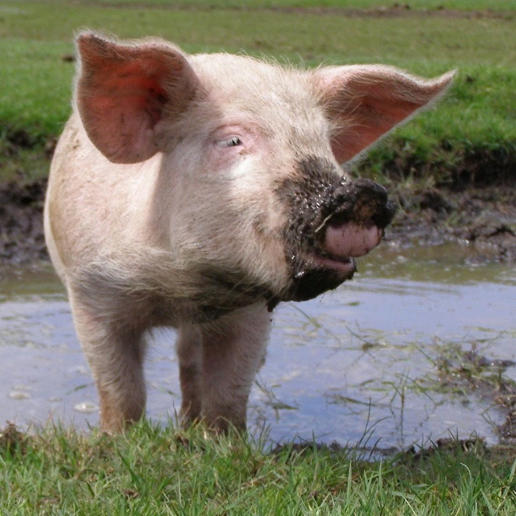
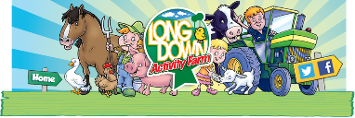
Pig
Pigs like to eat vegetable peelings, grass and small insects. They also love scraps of leftover food.
Pigs love the mud. They live on a farm in fields. Sometimes they live in pig stys. They like to wallow in muddy puddles.
What does it gives us?
Interesting Facts
Habitat
Diet

Pigs give us bacon, ham, sausages and pork chops.
They also make fun pets.
There are around 2 billion pigs in the world.
Pigs have an excellent sense of smell.

