My Story Hill
Title: This is the and the Scary Night Author:

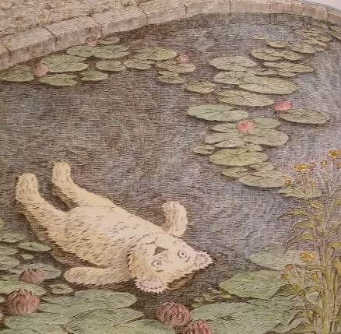
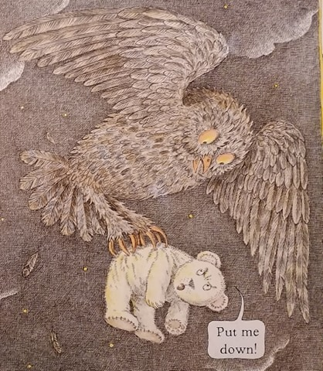
Original story: ‘This is the BEAR and the Scary Night’ written by Sarah Hayes

