Push and Pull
How do these things move? Do you push or pull them?
Put a tick in the correct box.
 | Push  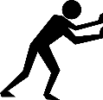 | Pull  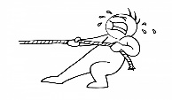  This Photo by Unknown Author is licensed under CC BY-SA | Both  This Photo by Unknown Author is licensed under CC BY-SA
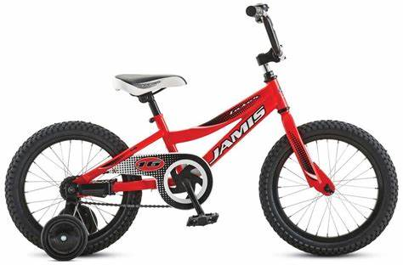
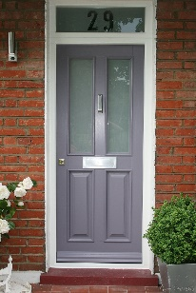
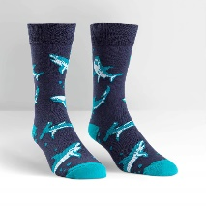
Put on your socks

Kick or throw a ball
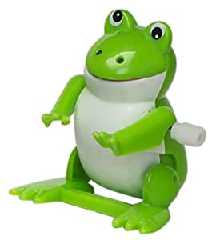
Wind-up toy
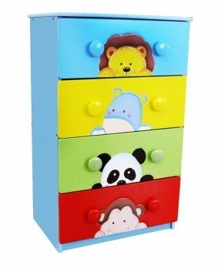
Open a drawer

