Teddy Bear

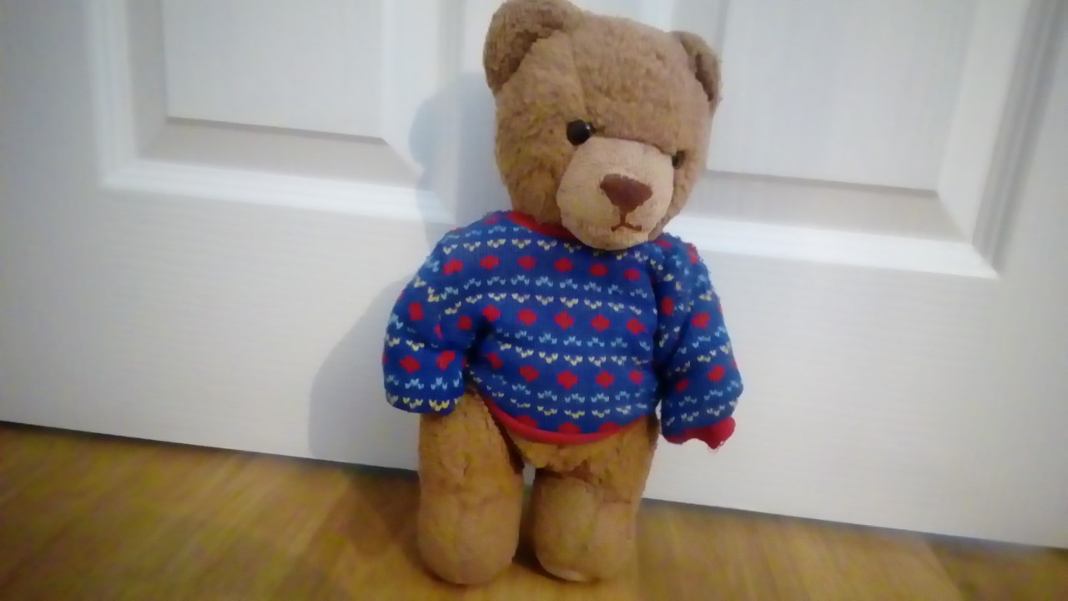

My toy is a teddy bear. He is called Sebastian.
I take him to bed with me and cuddle him.
He is brown and soft. He is made of fabric.
His arms and legs move and he has a blue jumper.
I got him the day I was born.

