Barbie Doll
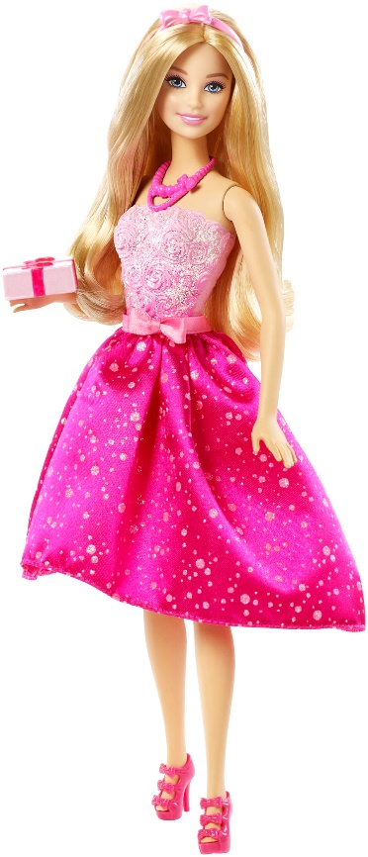

My toy is a doll. She is called Barbie.
I loved dressing her up in different clothes and brushing her hair.
She has long blonde hair and a pretty pink dress.
She is made from plastic.
I got her when I was 4 years old.

