Once Upon A Time
Home Learning

After The Three Little Pigs had got rid of the Big Bad Wolf, they enjoyed living together in the brick house. However, after a while they decided it was too small for all of them and they needed to build a new house.
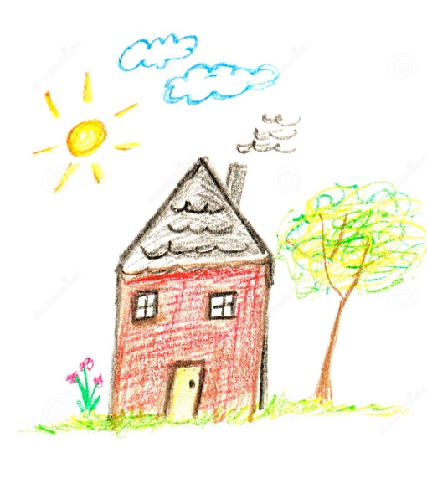
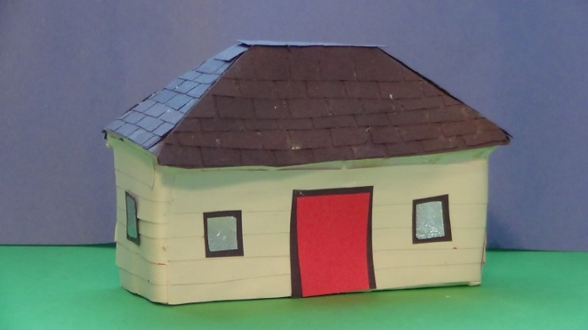
Draw or make a new house that you have designed for The Three Little Pigs. With help label it to show why it is perfect for them. Think about which materials would make a strong, waterproof and wolf proof house.



