Circle the Word
Circle the word that matches the picture.
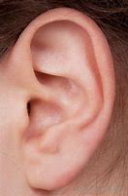 | era  ear  ear  iear
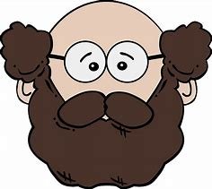 | burd  beard  beed
 | tear  ear  tair  ture
 | jear  year  yure
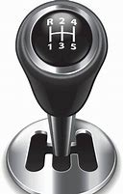 | near  gear  jeer

