Circle the pictures that make the ‘ow’ sound.
Can you write the ‘ow’ word underneath the picture?

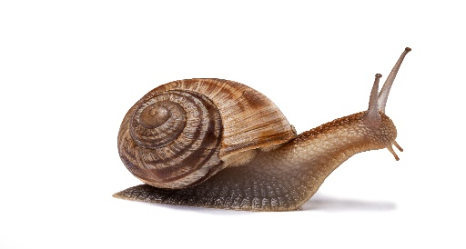

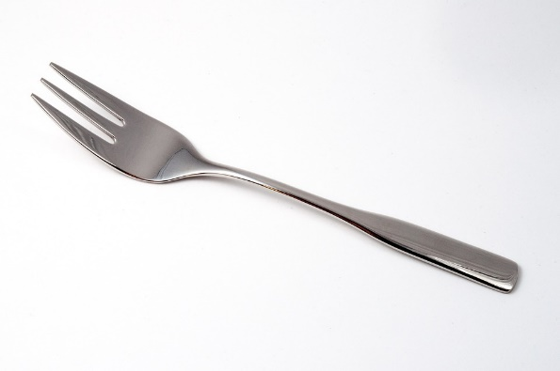
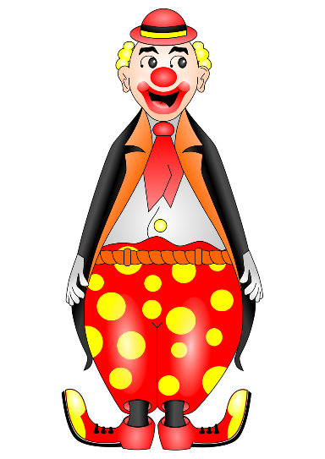
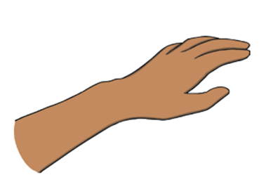

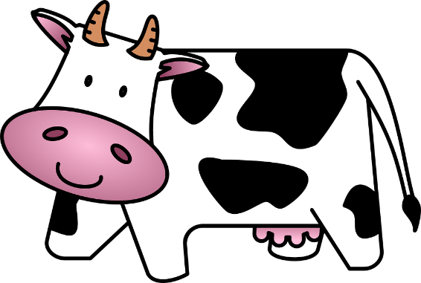
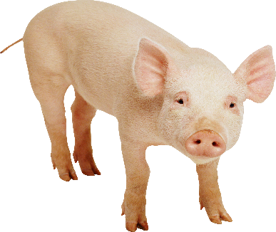
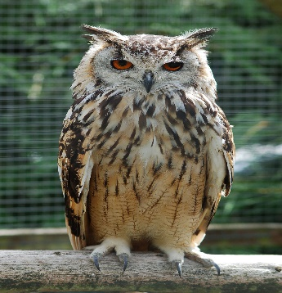

This Photo by Unknown Author is licensed under CC BY-NC
This Photo by Unknown Author is licensed under CC BY-SA
This Photo by Unknown Author is licensed under CC BY-NC
This Photo by Unknown Author is licensed under CC BY-SA
This Photo by Unknown Author is licensed under CC BY-SA

