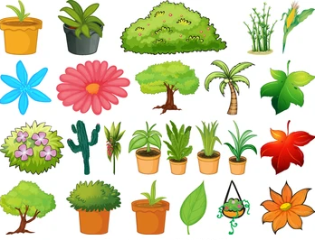
Comparing Plants

What did you notice that was the same?

What did you notice that was different?

